Test Case: tc001_SPX_Dev5_Crear_Solicitud_Articulo_Almacen
Step 1 - Enter username and password and click to button Enter : Credentials Entered
Image file-name: QC_Testing-tc001_SPX_Dev5_Crear_Solicitud_Articulo_Almacen-1787940944664

Step 2 - Select to UEN and Access to Request for a New Inventory Item : UEN Correctly selected and Correct access
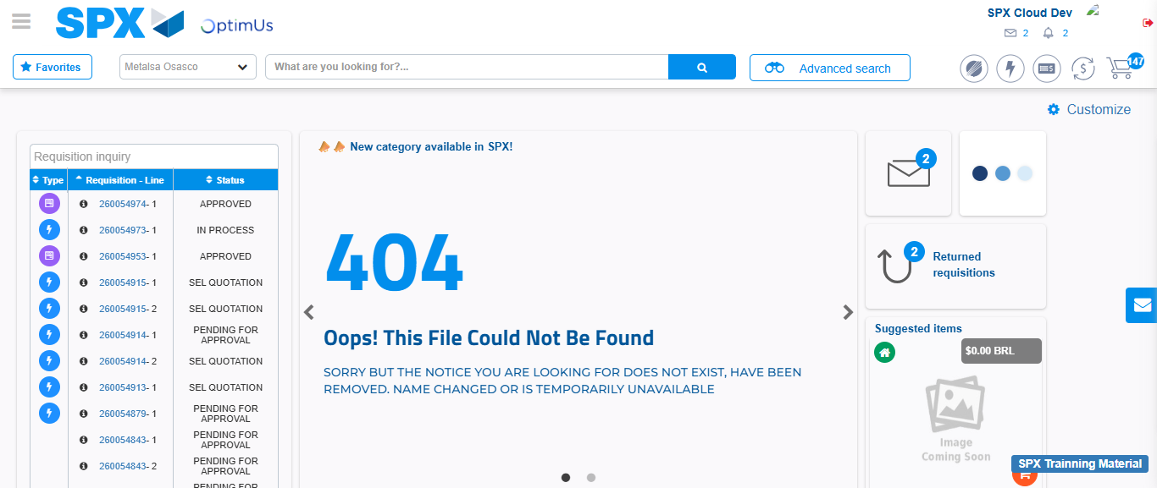Image file-name: QC_Testing-tc001_SPX_Dev5_Crear_Solicitud_Articulo_Almacen-1787940971536

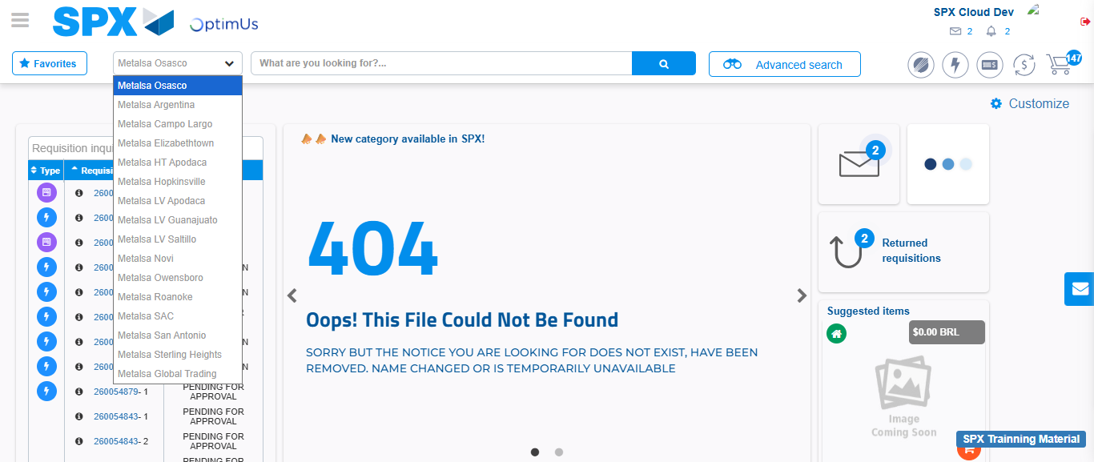Image file-name: QC_Testing-tc001_SPX_Dev5_Crear_Solicitud_Articulo_Almacen-1787940972154

Image file-name: QC_Testing-tc001_SPX_Dev5_Crear_Solicitud_Articulo_Almacen-1787941001287

Step 3 - Select options first section : Options seleted correctly
Image file-name: QC_Testing-tc001_SPX_Dev5_Crear_Solicitud_Articulo_Almacen-1787941001642

Image file-name: QC_Testing-tc001_SPX_Dev5_Crear_Solicitud_Articulo_Almacen-1787941001888

Step 4 - Select options at Screen: Options seleted correctly
Image file-name: QC_Testing-tc001_SPX_Dev5_Crear_Solicitud_Articulo_Almacen-1787941001642

Image file-name: QC_Testing-tc001_SPX_Dev5_Crear_Solicitud_Articulo_Almacen-1787941001888

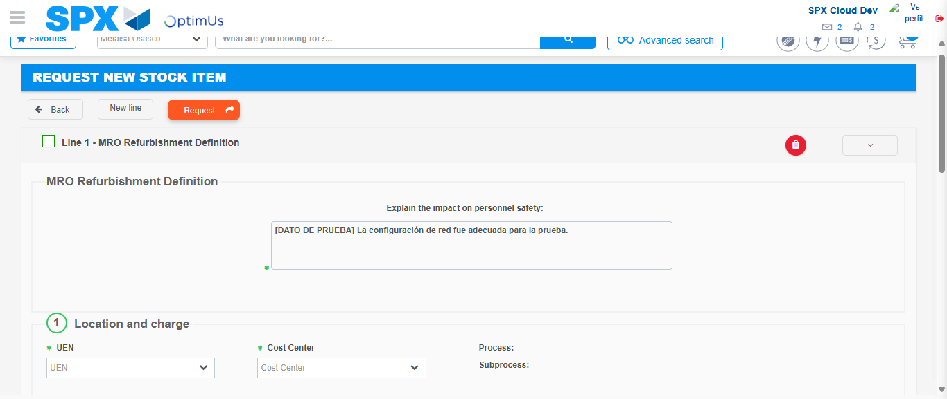Image file-name: QC_Testing-tc001_SPX_Dev5_Crear_Solicitud_Articulo_Almacen-1787941009109

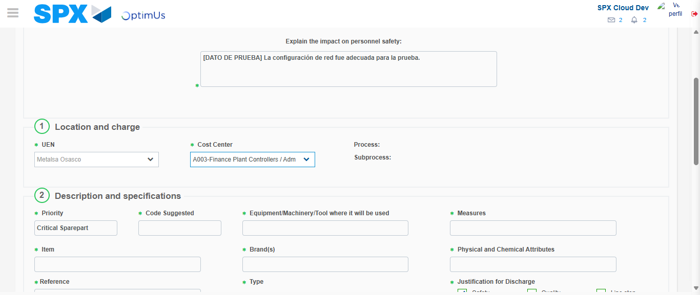Image file-name: QC_Testing-tc001_SPX_Dev5_Crear_Solicitud_Articulo_Almacen-1787941012489

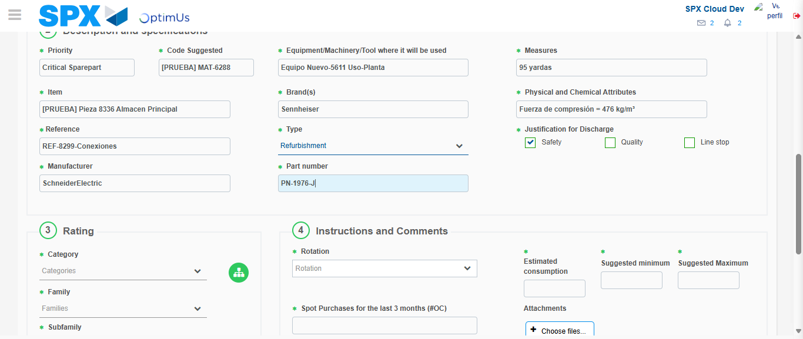Image file-name: QC_Testing-tc001_SPX_Dev5_Crear_Solicitud_Articulo_Almacen-1787941015264

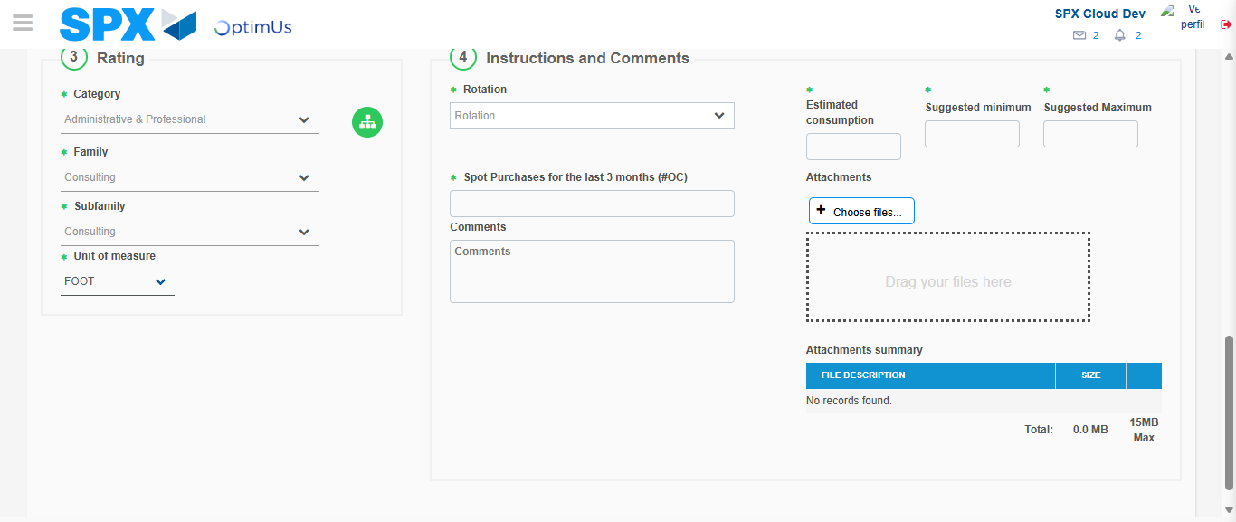Image file-name: QC_Testing-tc001_SPX_Dev5_Crear_Solicitud_Articulo_Almacen-1787941021281

Step 5 - Request New Item : Request Accepted
Image file-name: QC_Testing-tc001_SPX_Dev5_Crear_Solicitud_Articulo_Almacen-1787940971536

Image file-name: QC_Testing-tc001_SPX_Dev5_Crear_Solicitud_Articulo_Almacen-1787940972154

Image file-name: QC_Testing-tc001_SPX_Dev5_Crear_Solicitud_Articulo_Almacen-1787941001287

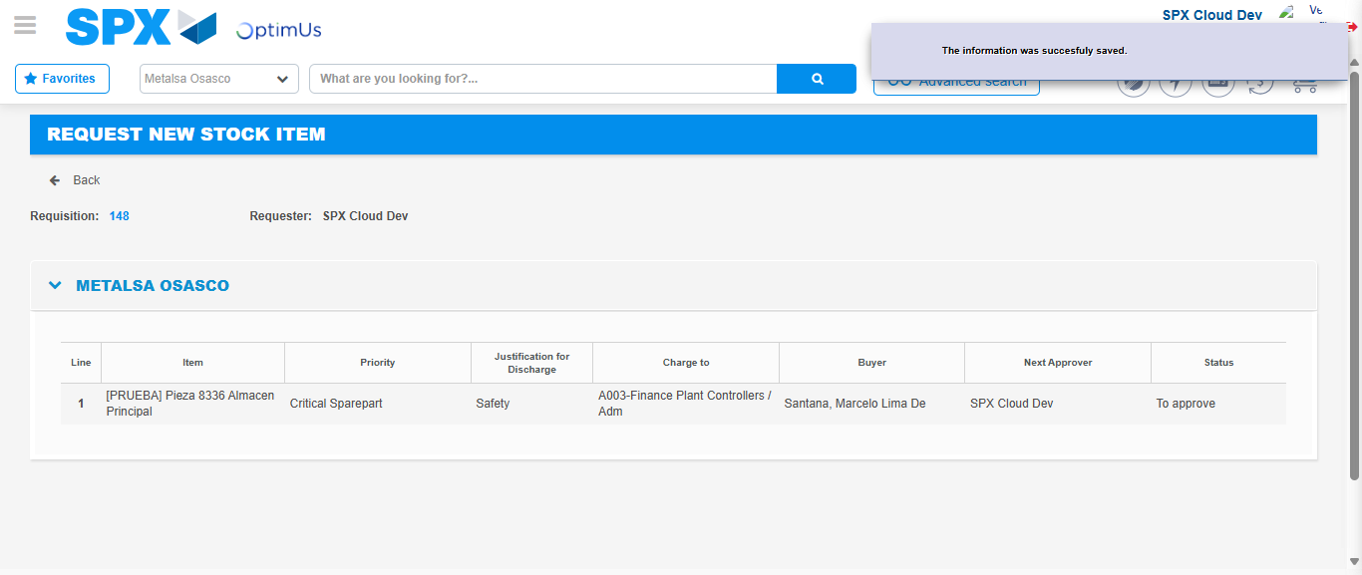Image file-name: QC_Testing-tc001_SPX_Dev5_Crear_Solicitud_Articulo_Almacen-1787941029303

Image file-name: QC_Testing-tc001_SPX_Dev5_Crear_Solicitud_Articulo_Almacen-1787941029573

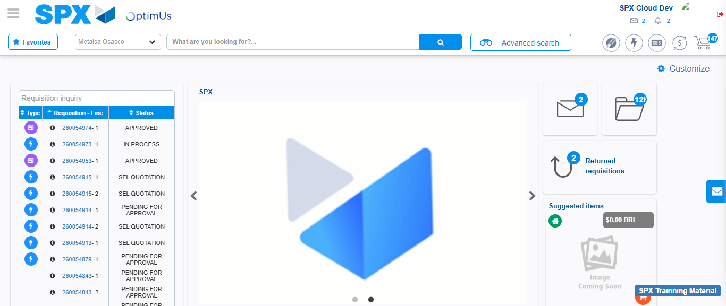Image file-name: QC_Testing-tc001_SPX_Dev5_Crear_Solicitud_Articulo_Almacen-1787941051320

Step 7 - Return to Main Page SPX : Return to Main Page SPX
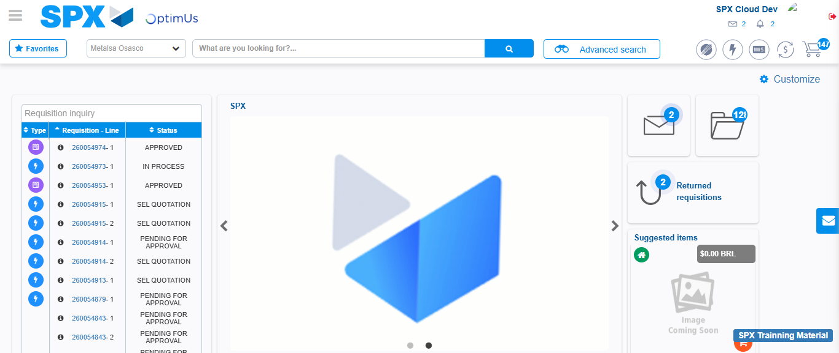Image file-name: QC_Testing-tc001_SPX_Dev5_Crear_Solicitud_Articulo_Almacen-1787941051752

